Diesel blazer with deisgn bunk
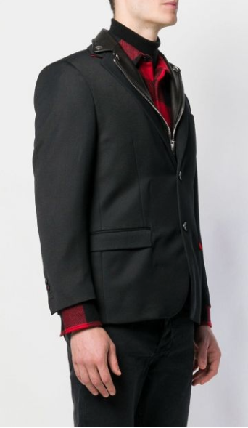
$733

Diesel deisgn superimposed blazer with notched lapels, buttonhole on the front, front flap pockets, long sleeves, buttoned cuffs and rear slit. Black color.

